Assisi Animal Health Announces a collaboration with Sleepypod.
An Innovative New Product for the Control of Pain and Inflammation
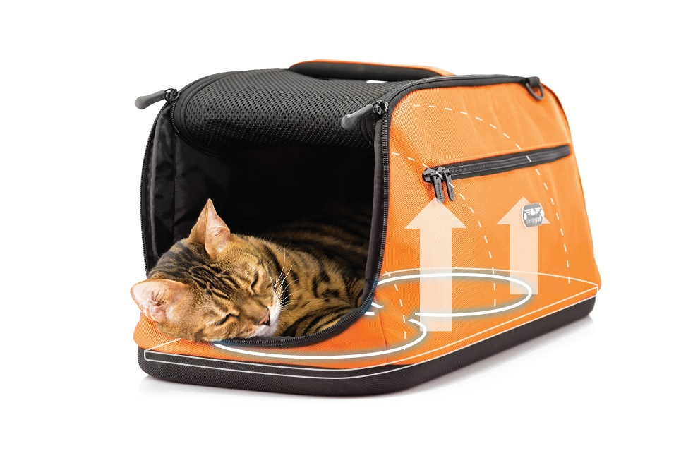
New York, NY – For years, many loyal Assisi Loop® customers have been asking for a pet bed that offers a "total body" solution for treating widespread pain and inflammation. Today, Assisi Animal Health is introducing the Assisi Loop Lounge™, a therapeutic pet bed powered by the Assisi Loop’s targeted pulsed electromagnetic field (tPEMFTM) technology.
In collaboration with Sleepypod®, the first models of the Assisi Loop Lounge have been designed for small animals. Sleepypod is the renowned maker of innovative, award-winning, crash-tested pet carriers, certified with a top safety rating from the Center for Pet Safety.
Assisi Loop technology has been cleared by the FDA and scientifically proven in both human and veterinary research. Incorporated in The Loop Lounge, therapy is delivered by multiple applicator coils embedded in cushy, foam therapy pads. The tPEMF™ Controller Box contains rechargeable batteries that can deliver 60 treatments on a single charge and last four years before replacement.
Inside a Sleepypod Atom or Sleepypod Air, the Loop Lounge therapy pads cover the entire floor area of each carrier. The pads’ 10-inch treatment depth assures that a pet, contained comfortably inside, receives therapy from nose-to-tail and from toes to top-of-ears.
In announcing the new product, L. John Wilkerson, Chairman of Assisi Animal Health, remarked: “We have collaborated with Sleepypod, investing in breakthrough engineering that can deliver safe, total body healing and relief for pets in pain. Assisi is proud of the resulting product and its potential to advance the standard of care, and of caring, that we can offer our pets.”
“Sleepypod carriers have transformed how pets travel,” says Michael Leung, Sleepypod co-founder. “As a leader in non-pharmaceutical anti-inflammatory technology, Assisi Animal Health is an ideal collaborative partner to Sleepypod. Through this collaboration, we as a team are moving the ball forward in companion animal care by delivering an inventive approach to body healing and pain relief.”
Assisi Loop Lounges with accompanying Sleepypod carriers are available from participating veterinary practices. With a prescription from a veterinary professional, they can also be purchased directly from Assisi Animal Health and from Sleepypod.
Assisi Loop Lounge models for larger animals will be introduced in mid-2019. For more information about Assisi Animal Health, visit our website at www.assisianimalhealth.com.
Assisi Animal Health offers clinical solutions that empower veterinary professionals, pet owners and their companion animals to achieve healing and health throughout life’s journey together. The company’s pet-friendly product line employs its patented, targeted, pulsed electromagnetic field (PEMF) anti-inflammatory technology. The technology is a non-invasive, non-pharmaceutical anti-inflammatory device (NPAID ®) that is FDA cleared for humans, and proven in clinical trials in veterinary medicine. Assisi’s prescription products, in conjunction with its Clinical Use Guide, deliver pain management, healing and quality of life for companion animals with a broad array of acute, chronic and degenerative inflammatory conditions.
Media Contact: Karolynne McAteer, Assisi Animal Health, 1-866-830-7342 ext 0, info@assisianimalhealth.com

