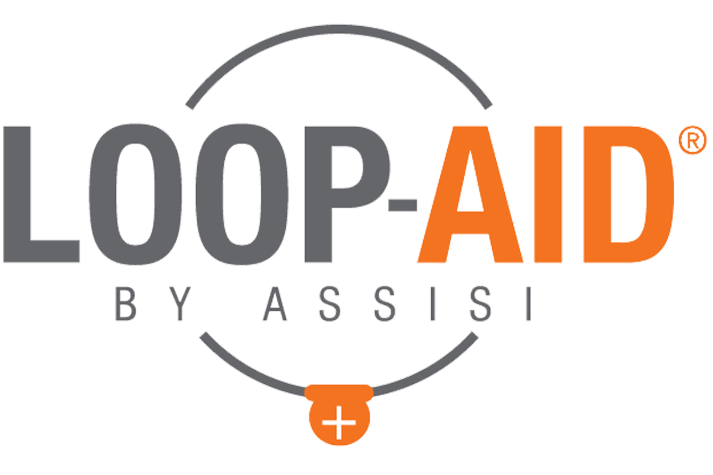

Assisi LOOP-AID® Website Content
For Veterinary Practices

Overview: The Assisi LOOP-AID®, an accessory for the Assisi Loop® from Assisi Animal Health, is designed to assist with compliance of veterinary instructions, provide convenience for pet owners, and enhance mobility for the pet during treatment. The LOOP-AID is available in a wide variety of sizes and is compatible with both the 10cm and 20cm Assisi Loop. It is completely washable and designed for reusability and ease of care. Ask us about the LOOP-AID at your next visit!

Compliance: In-home compliance with veterinary instruction is integral for an effective treatment program. The Assisi LOOP-AID® helps ensure that your pet is getting the most out of each Assisi Loop® treatment.

Convenience: Whether it’s being used in your vet’s office, at home, or on-the-go, the LOOP-AID® allows the caretaker to step away from patients without interfering with Assisi Loop® treatment.

Mobility: The LOOP-AID® allows pets to change positions and move freely during treatments with the Assisi Loop® without compromising the effectiveness of the treatment. With the LOOP-AID®, there will never be a need to interrupt a healing session!

