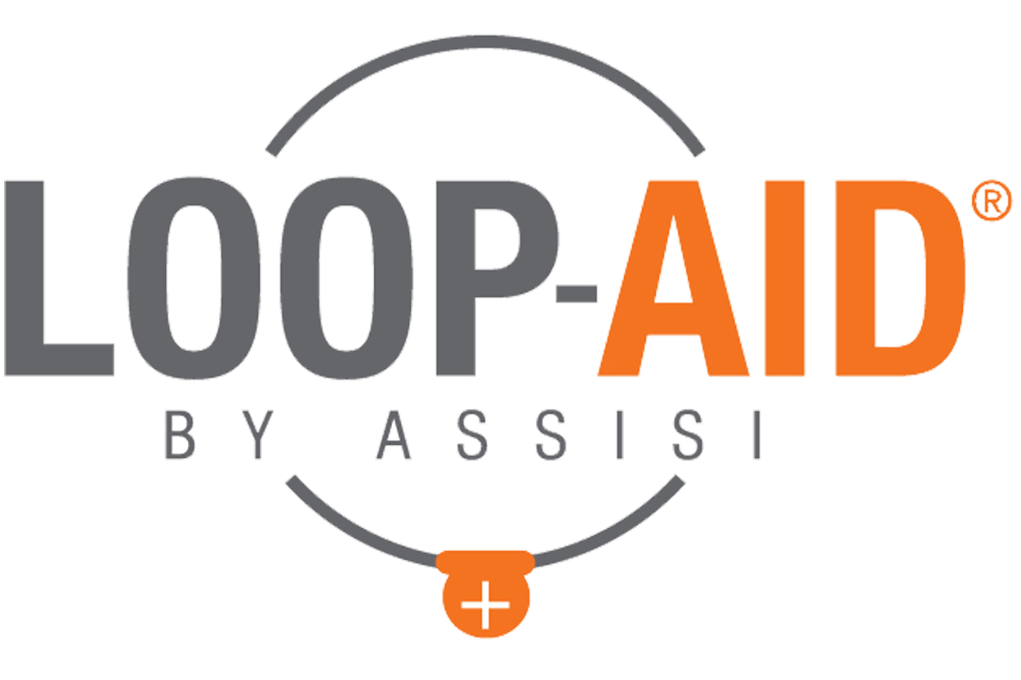
LOOP-AID® LAUNCH CONTENT

Copy | Images
Introducing the latest innovation from Assisi Animal Health: the Assisi LOOP-AID® Torso Wrap! This accessory to the Assisi Loop® promotes convenience for you and mobility for your pet. Ask us about the LOOP-AID today. [link]* | 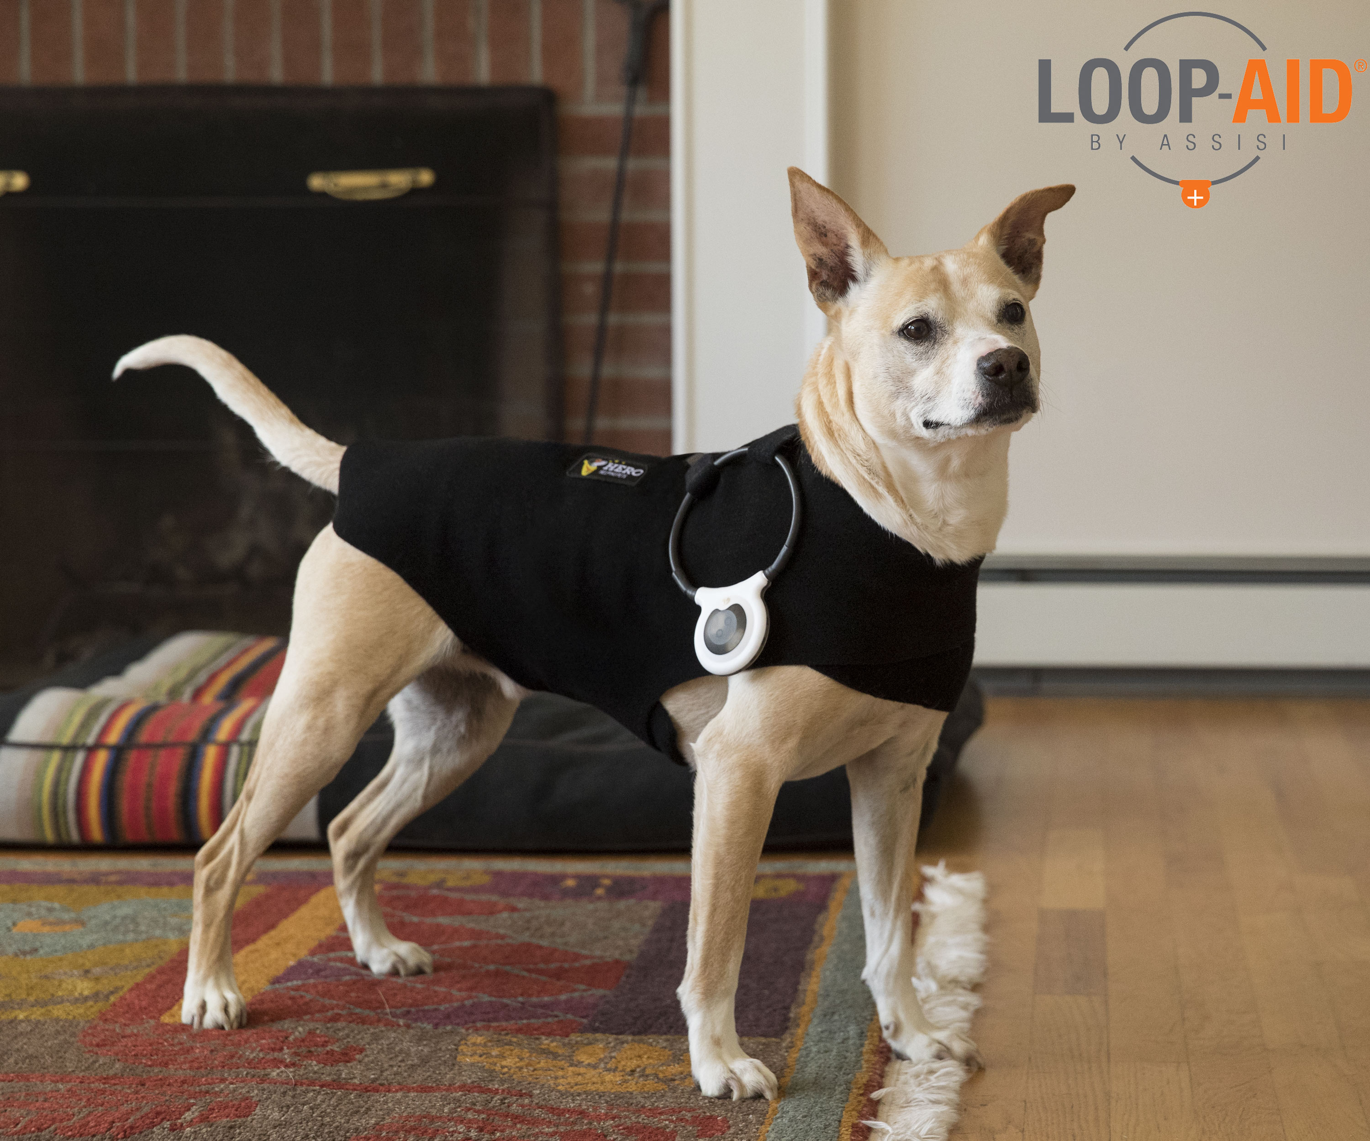
The Assisi LOOP-AID® is a new accessory to the Assisi Loop® designed to assist in compliance with veterinary instructions, enhance pet owner convenience, and allow pet mobility. Learn more about the LOOP-AID: [link] | 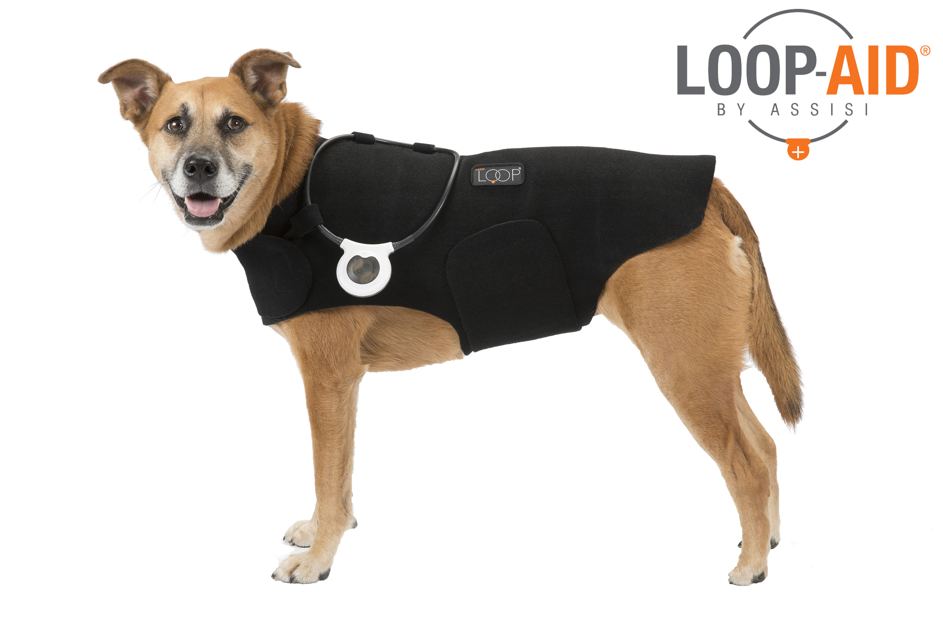
With multiple sizes available, your pet will be covered with the Assisi LOOP-AID® – no matter how big or small! Ask us about the LOOP-AID: [link]* | 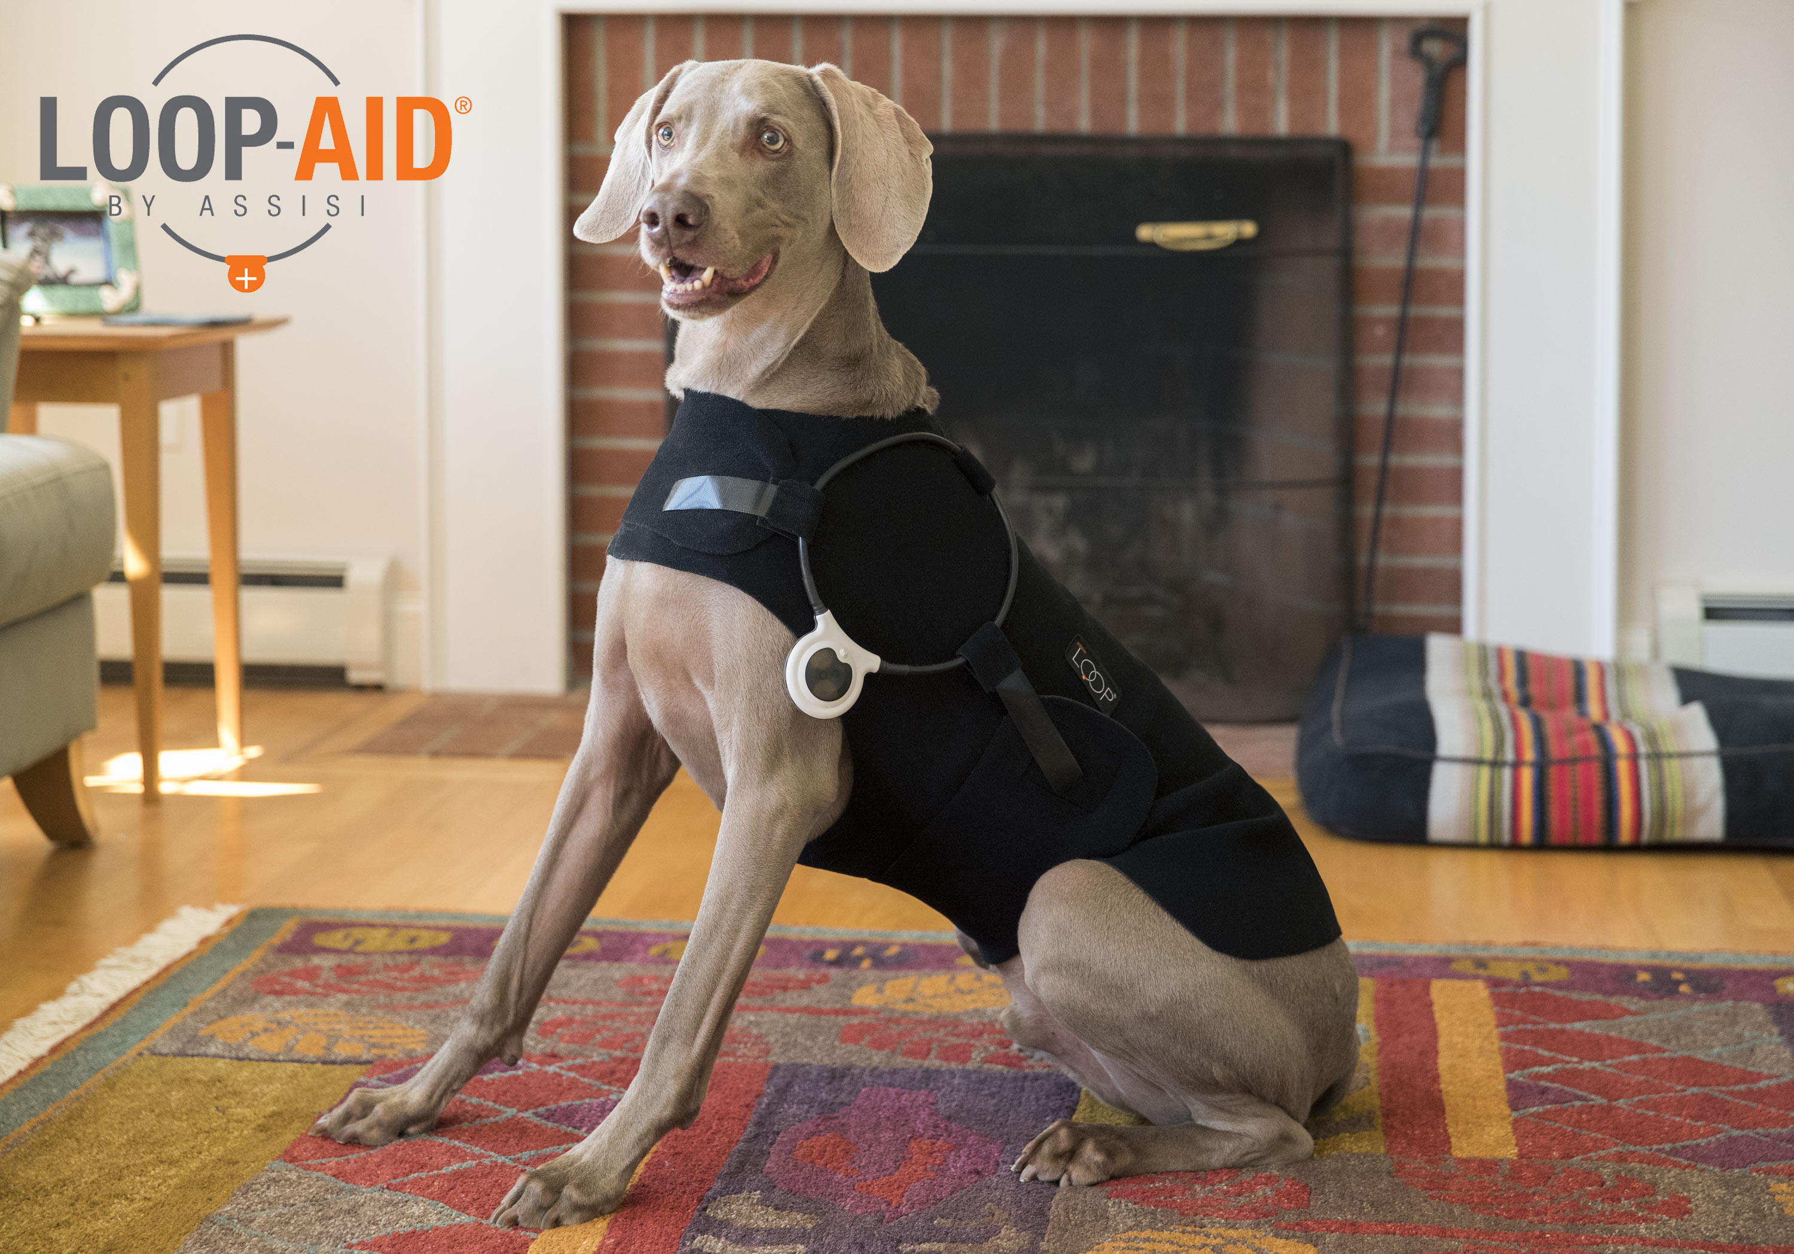
We are happy to announce that (practice name) now carries the Assisi LOOP-AID® Torso Wrap. The LOOP-AID is designed to give your pet mobility while still getting their Assisi Loop® treatments so you don’t have to hold the Loop! Order yours today: [link]* | 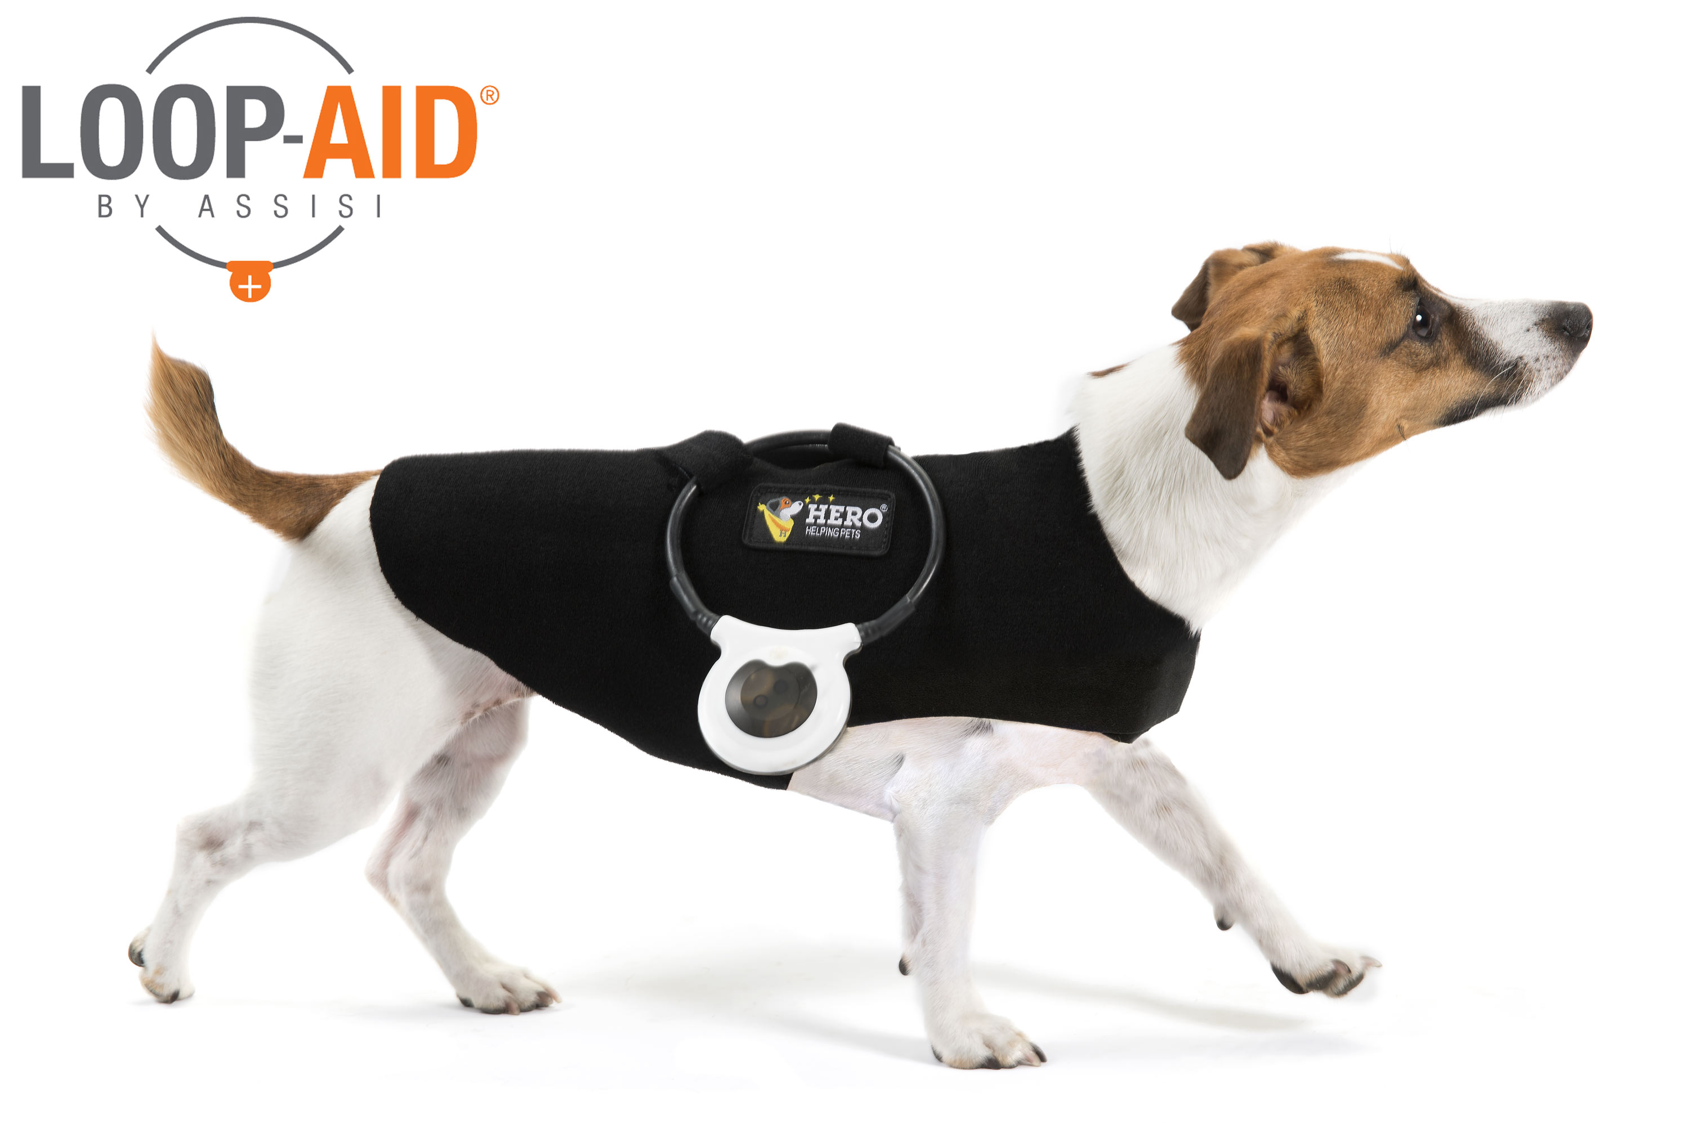
The Assisi LOOP-AID®, an accessory to the Assisi Loop®, is designed to assist with compliance with your vet’s instructions, provide convenience for you, and enhance your pet’s mobility during treatments. Ask us about the LOOP-AID bundle today: [link]* | 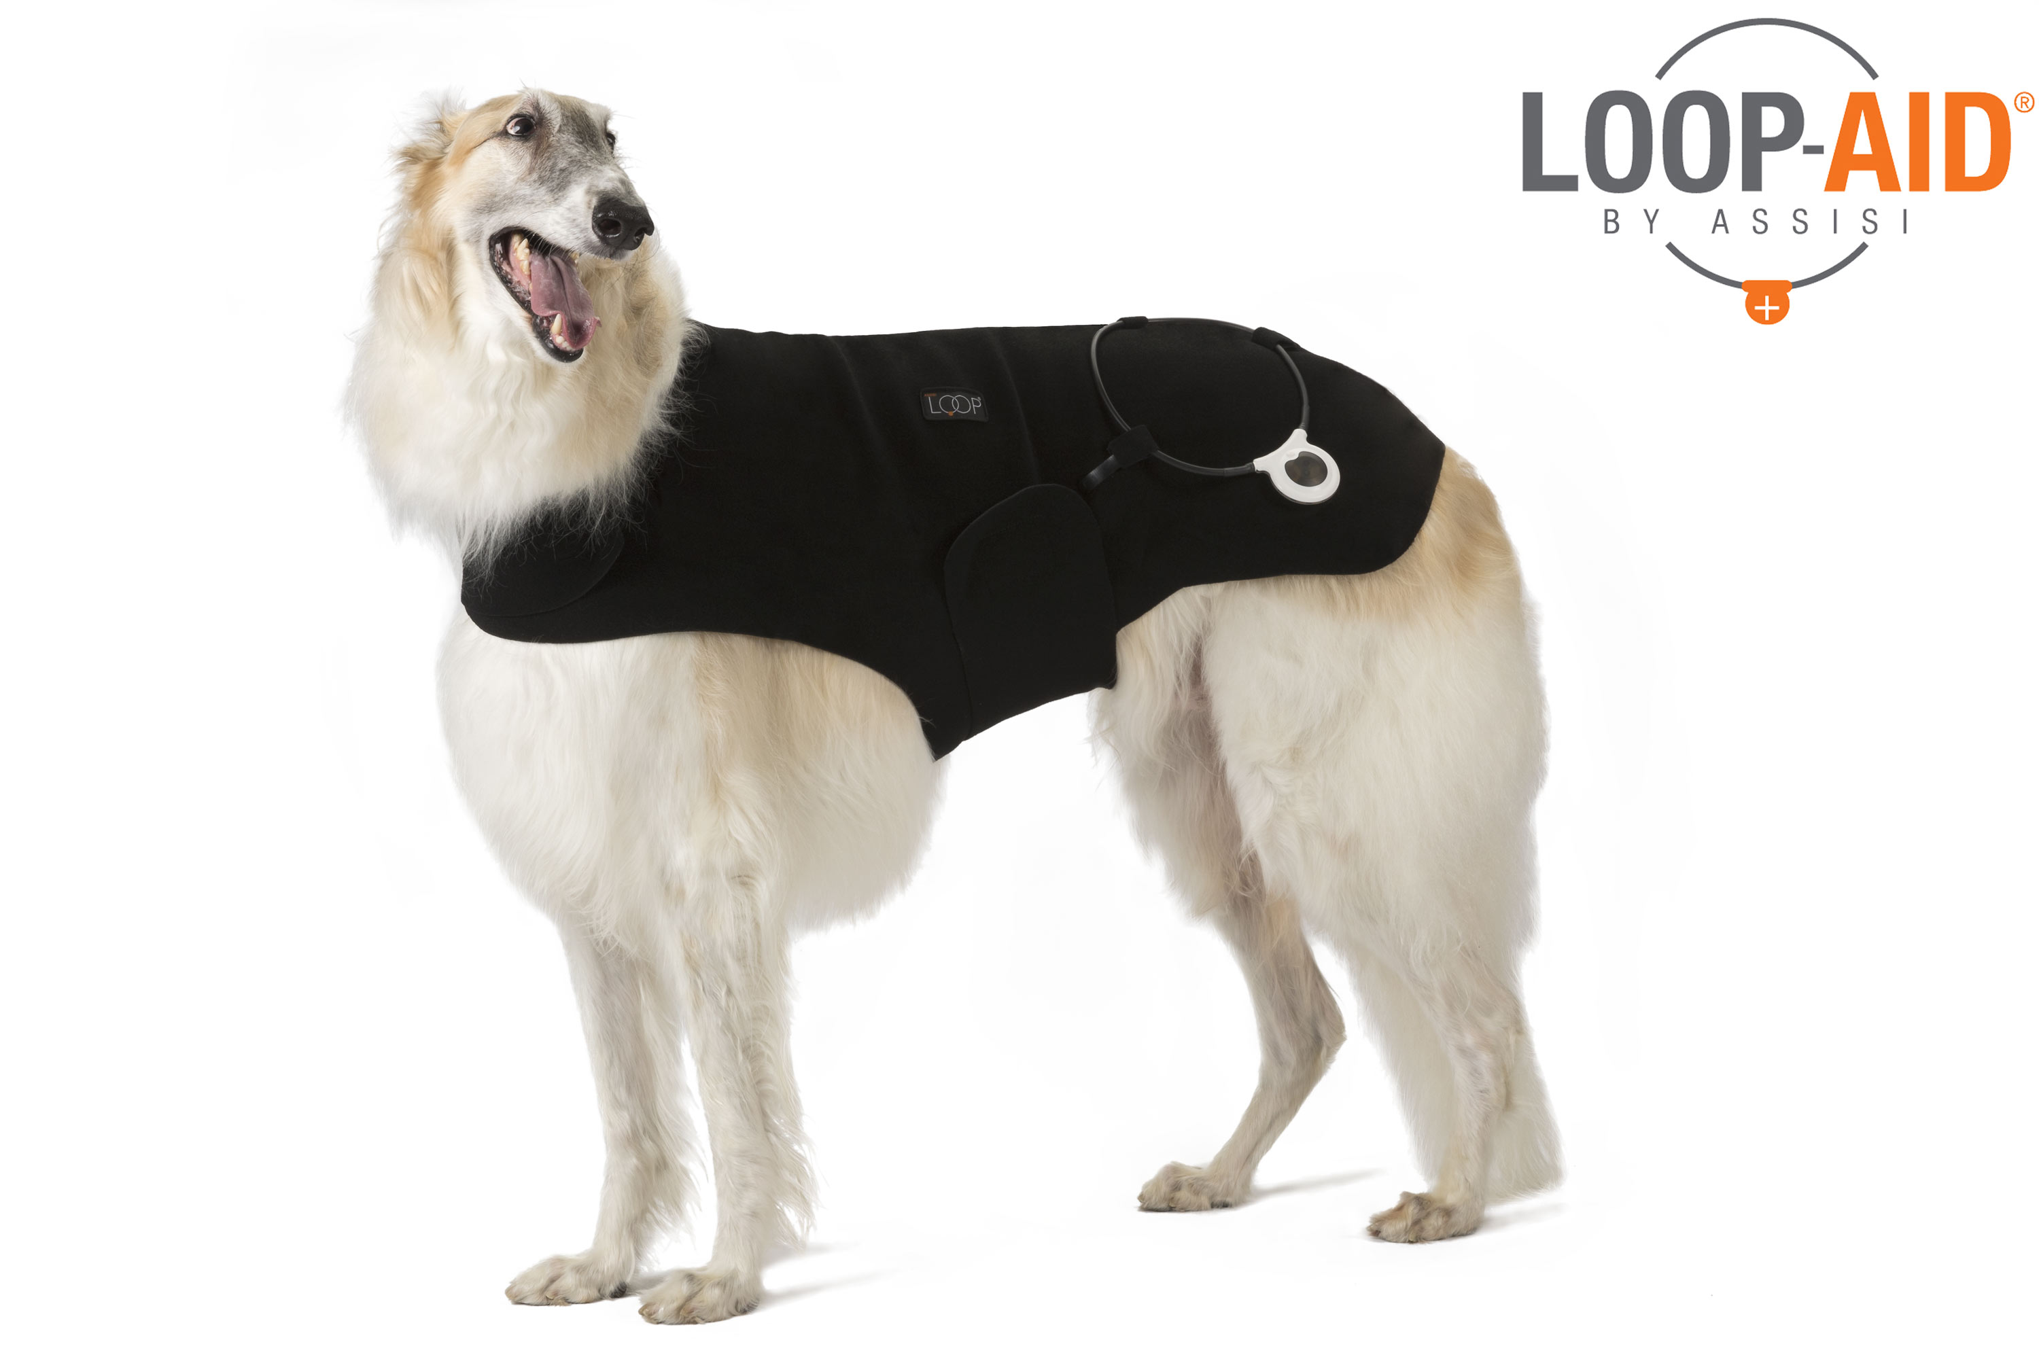
Get an Assisi Loop and an Assisi LOOP-AID® for your pet today! Ask us about our bundle deals: [link]* | 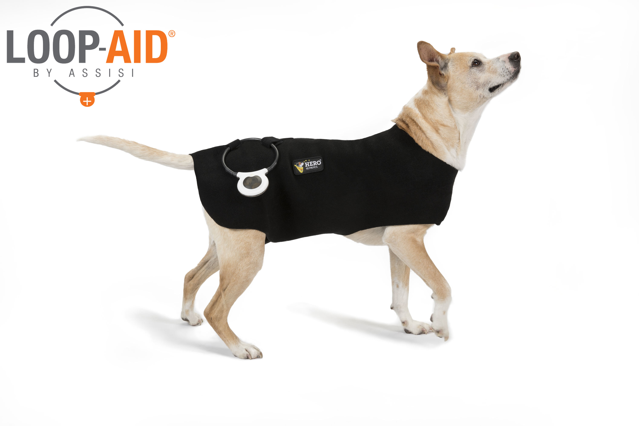
The Assisi Loop® just got even easier to use! Check out the new Assisi LOOP-AID® Torso Wrap. Now available! [link] | 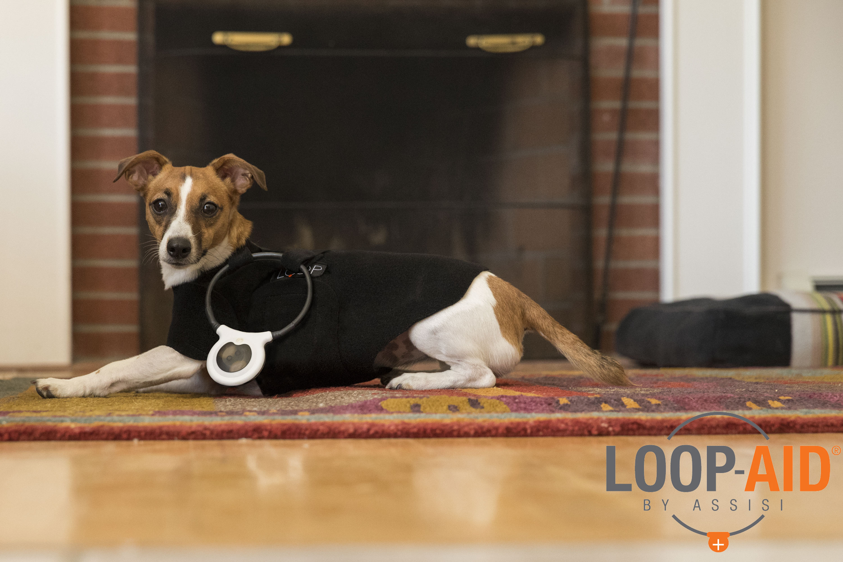
Convenience, compliance, and mobility. Introducing the Assisi LOOP-AID®! Ask us about the LOOP-AID. [link]* | 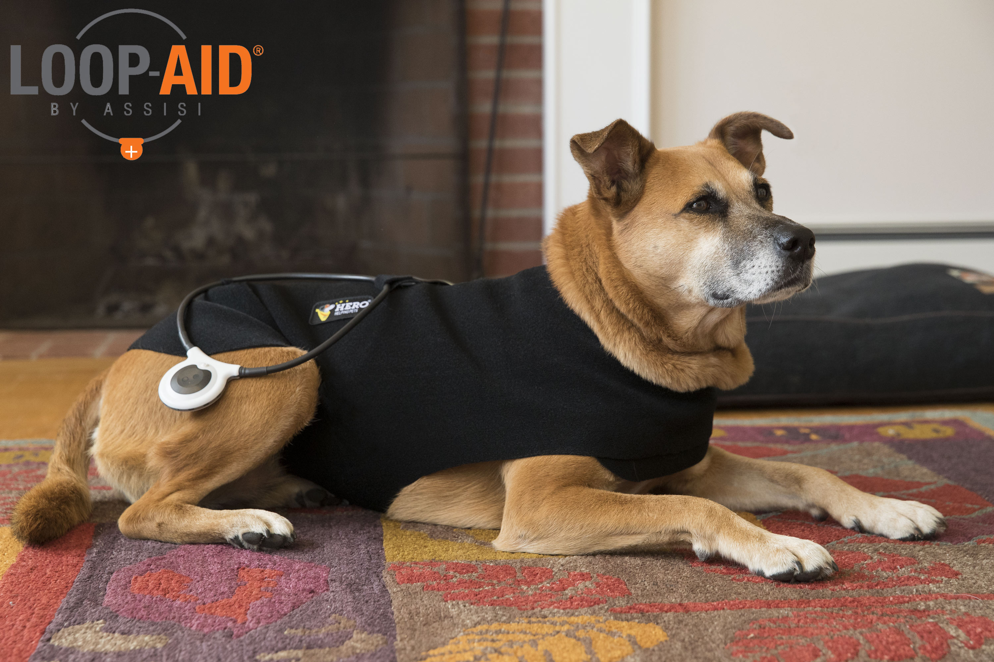
Get the most out of every Assisi Loop® treatment with the Assisi LOOP-AID®. Learn more about the LOOP-AID today. [link] | 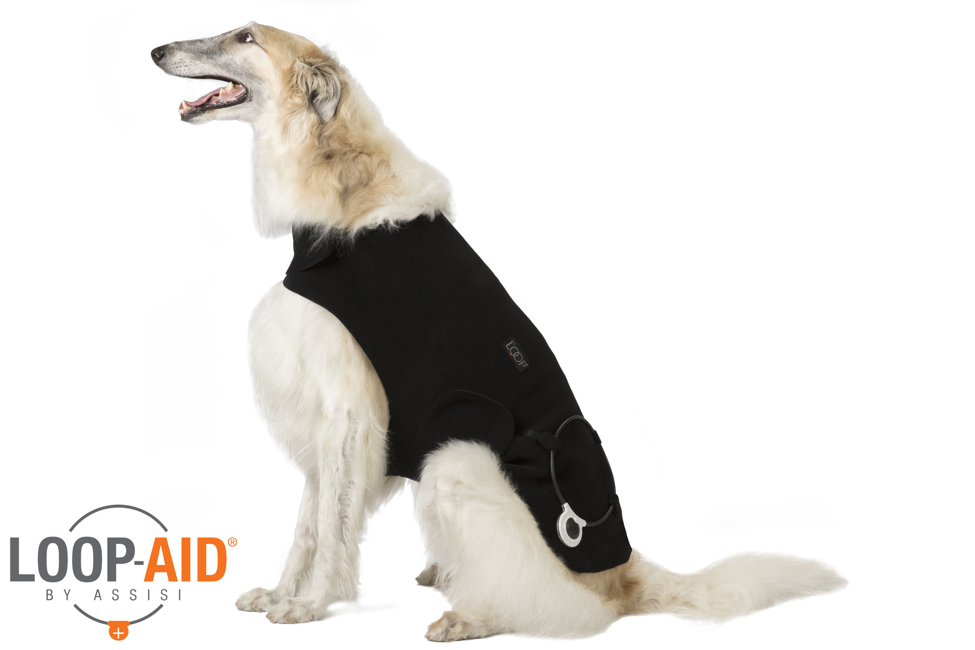
As an Assisi Animal Health Approved Provider, we’re happy to announce the release of the Assisi LOOP-AID®, an accessory to the Assisi Loop®. Ask us about the LOOP-AID at your next visit. [link]* | 