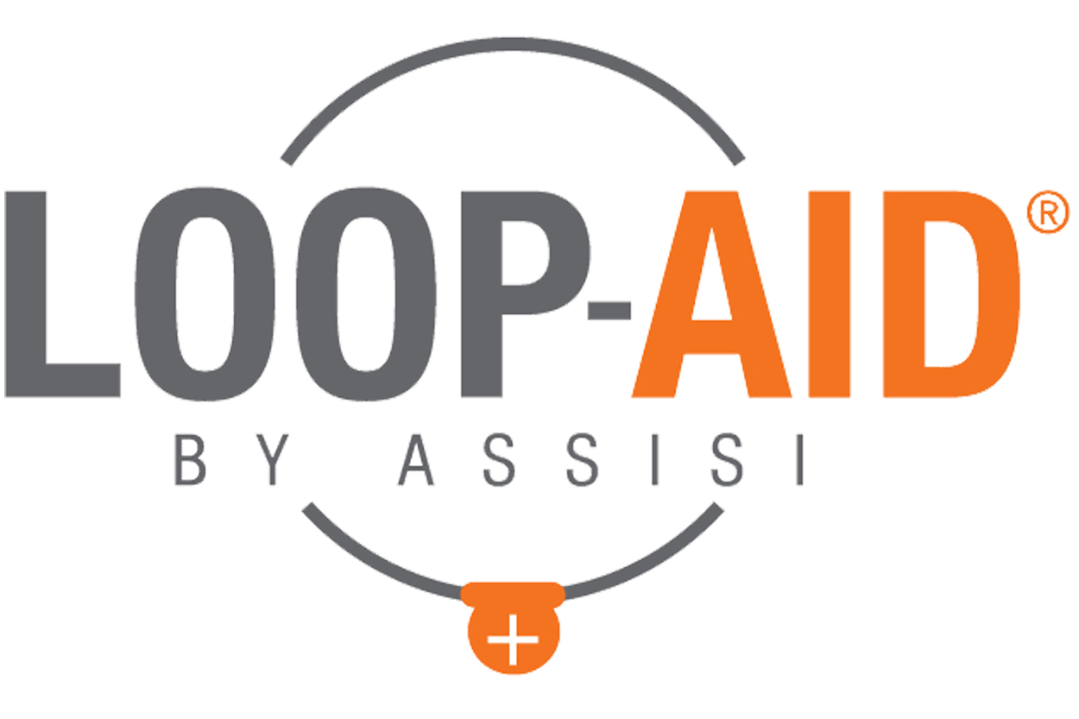
Assisi LOOP-AID® Ad Concepts

General Product
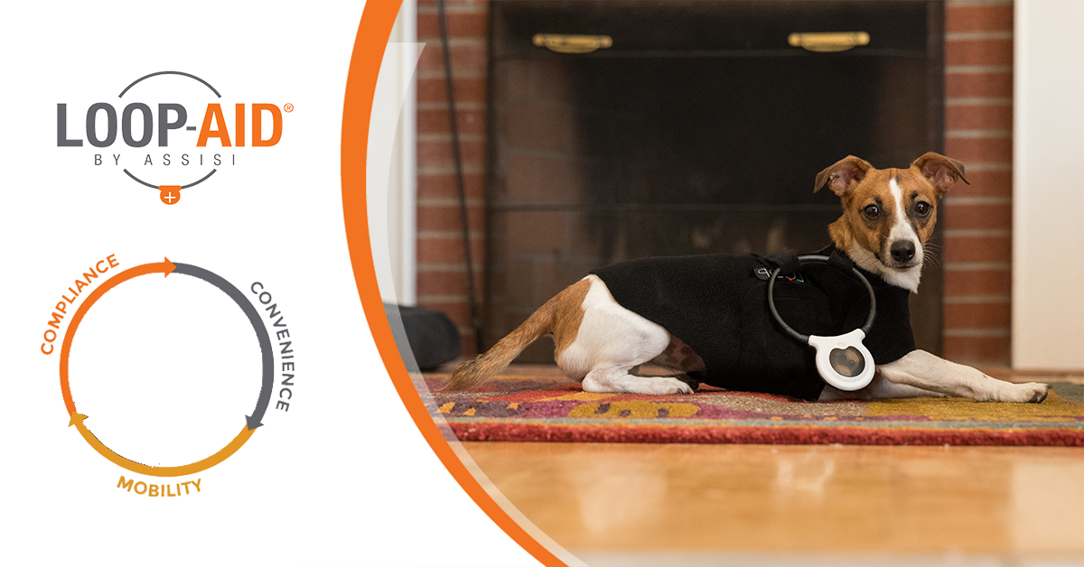
Copy Option 1: Introducing the Assisi LOOP-AID®, an accessory to the Assisi Loop®, the latest innovation from Assisi Animal Health. The LOOP-AID was designed to assist with compliance of veterinary instructions, provide convenience for you, and enhance your pet’s mobility during treatment. Available now!
Copy Option 2: The Assisi LOOP-AID® is designed to get the most out of every Assisi Loop® treatment by giving your pet more mobility during each treatment and giving you the freedom to step away from your pet without interrupting a healing session. Now available!
Copy Option 3: The Assisi LOOP-AID®, an accessory to the Assisi Loop®, is designed to promote compliance with your vet’s treatment program, increase your pet’s mobility during treatments, and allows you to step away while treatments continue. Now available!

LOOP-AID Promo
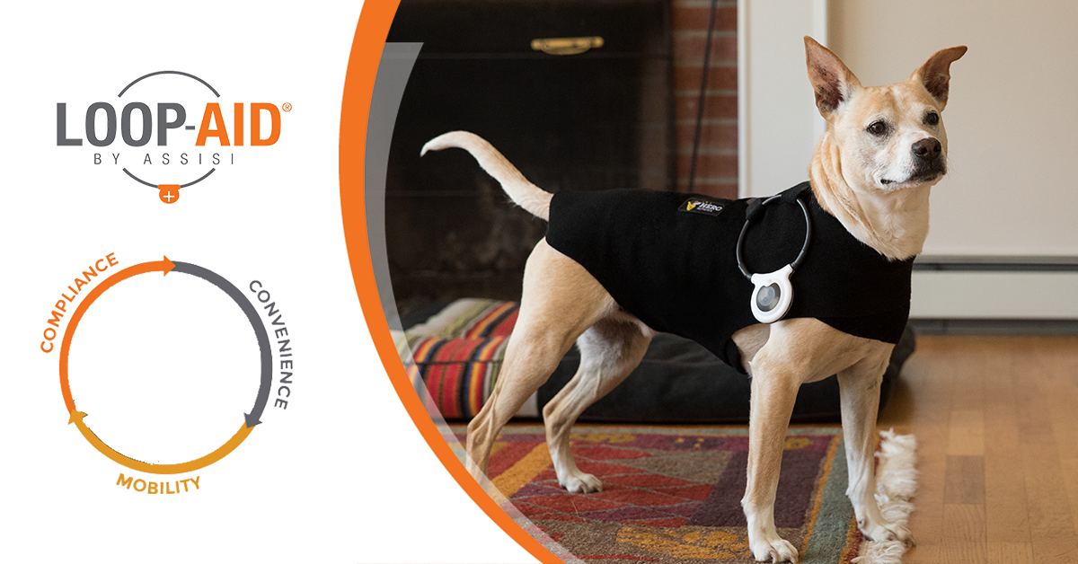
Copy Option 1: You already use the Assisi Loop®, now it’s time to make treatment even easier. Get the Assisi LOOP-AID® today to give your pet greater mobility during treatment, and give yourself the freedom to step away during each healing session. Now available!
Copy Option 2: Using the Assisi Loop® just got even easier! The Assisi LOOP-AID® is designed to get the most out of every healing session for your pet. Now available!
Copy Option 3: Healing at home just got even easier. The Assisi LOOP-AID® helps make the most out of every healing session with the Assisi Loop®. Order your LOOP-AID today!

Bundle Promo
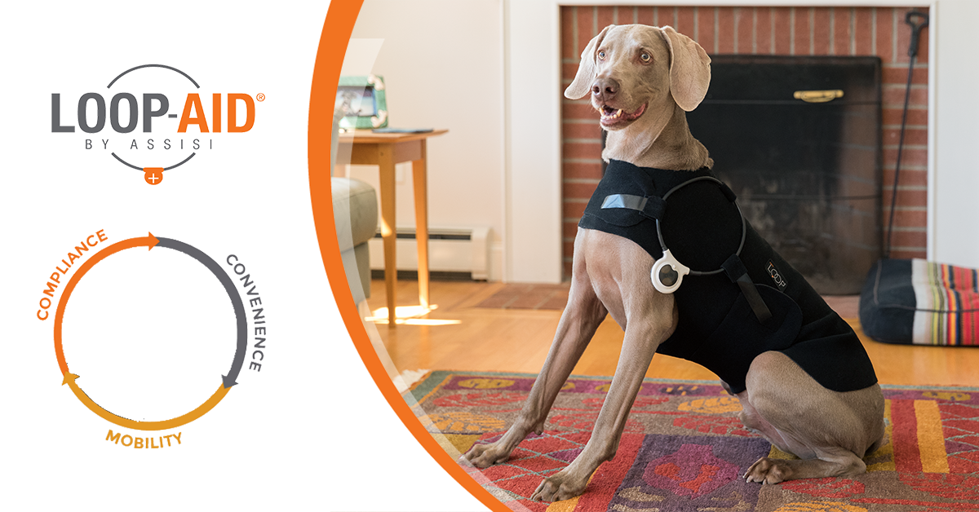
Copy Option 1: Introducing the Assisi LOOP-AID®, the most convenient way to treat your pet all in one place. Get an Assisi Loop® and LOOP-AID bundle today!
Copy Option 2: The Assisi Loop® and the Assisi LOOP-AID® are designed to make in-home healing as easy and worry-free as possible. Get your Assisi Loop and LOOP-AID bundle today!
Copy Option 3: Heal your pet at home with the Assisi Loop® and the Assisi LOOP-AID®. The most convenient way to treat your pet, all in one place. Get your Assisi Loop and LOOP-AID bundle today!

