Assisi Animal Health
Media Kit for Assisi Loop Providers
Copy for Social Media Post

Copy | Image
Reducing inflammation is a critical first step in healing. To bring our clients the newest and best advancements in pet health, we now offer the Assisi Loop® 2.0, a revolutionary device that greatly reduces inflammation without the use of drugs or invasive technology.  Contact us for information about the Assisi Loop and whether or not it would help your pet. Visit assisianimalhealth.com to learn more about the Loop. | 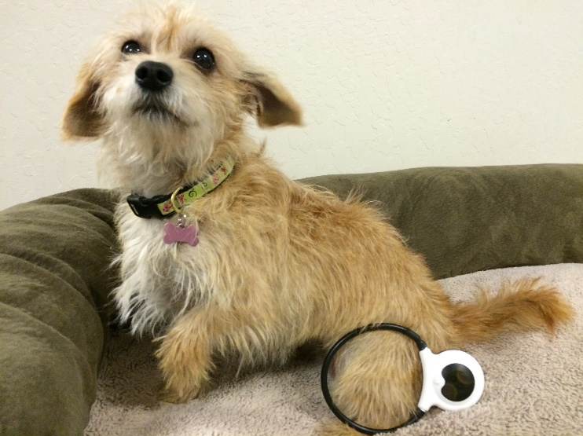
We are happy to announce that (Practice Name) is now carrying the Assisi Loop® 2.0, a revolutionary device that reduces or even eliminates inflammation without the use of drugs. With the Assisi Loop, you can bring healing into your own home. Ask us about the Loop at your next visit! | 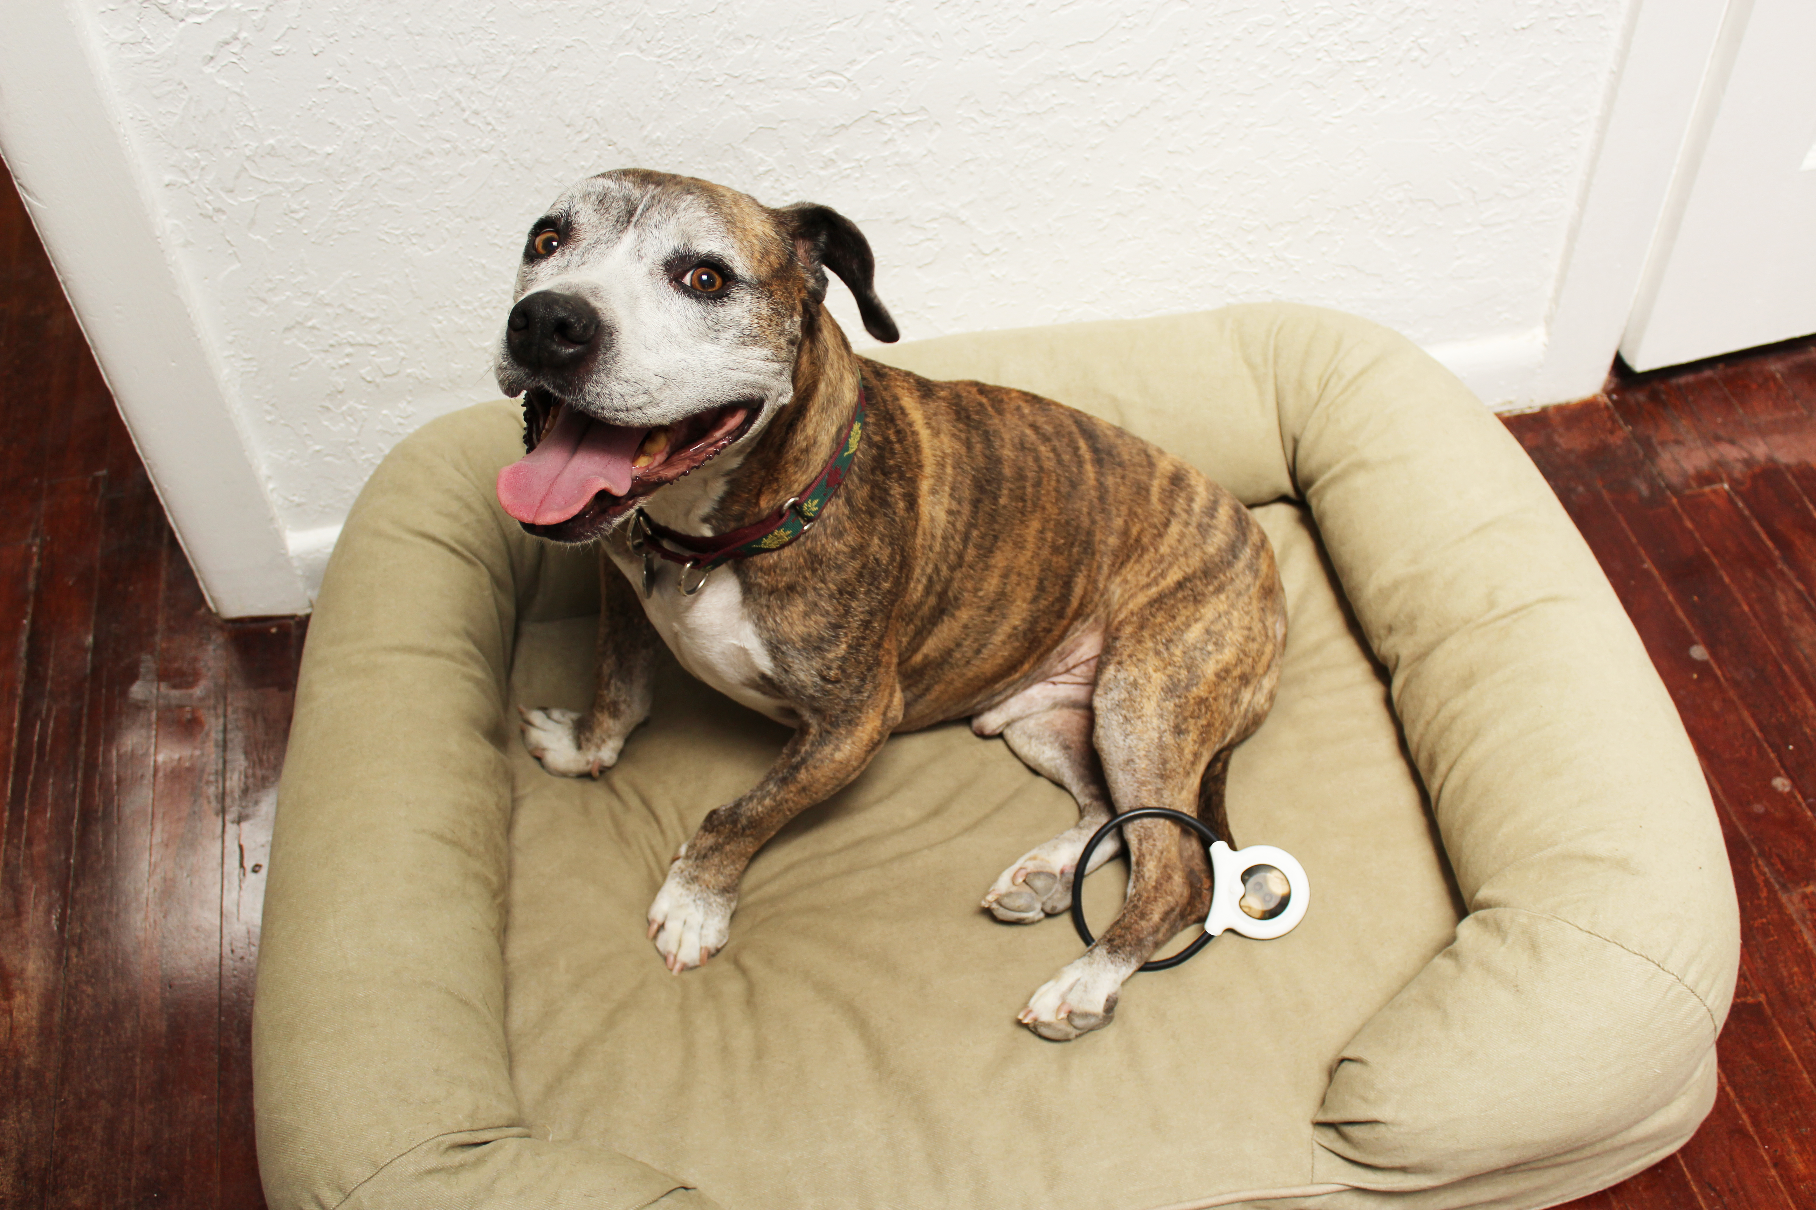
We are now carrying the Assisi Loop® 2.0 at (Practice Name)! The Loop is a device that uses electromagnetic therapy to reduce inflammation and pain in pets. As us about the Assisi Loop at your next visit! | 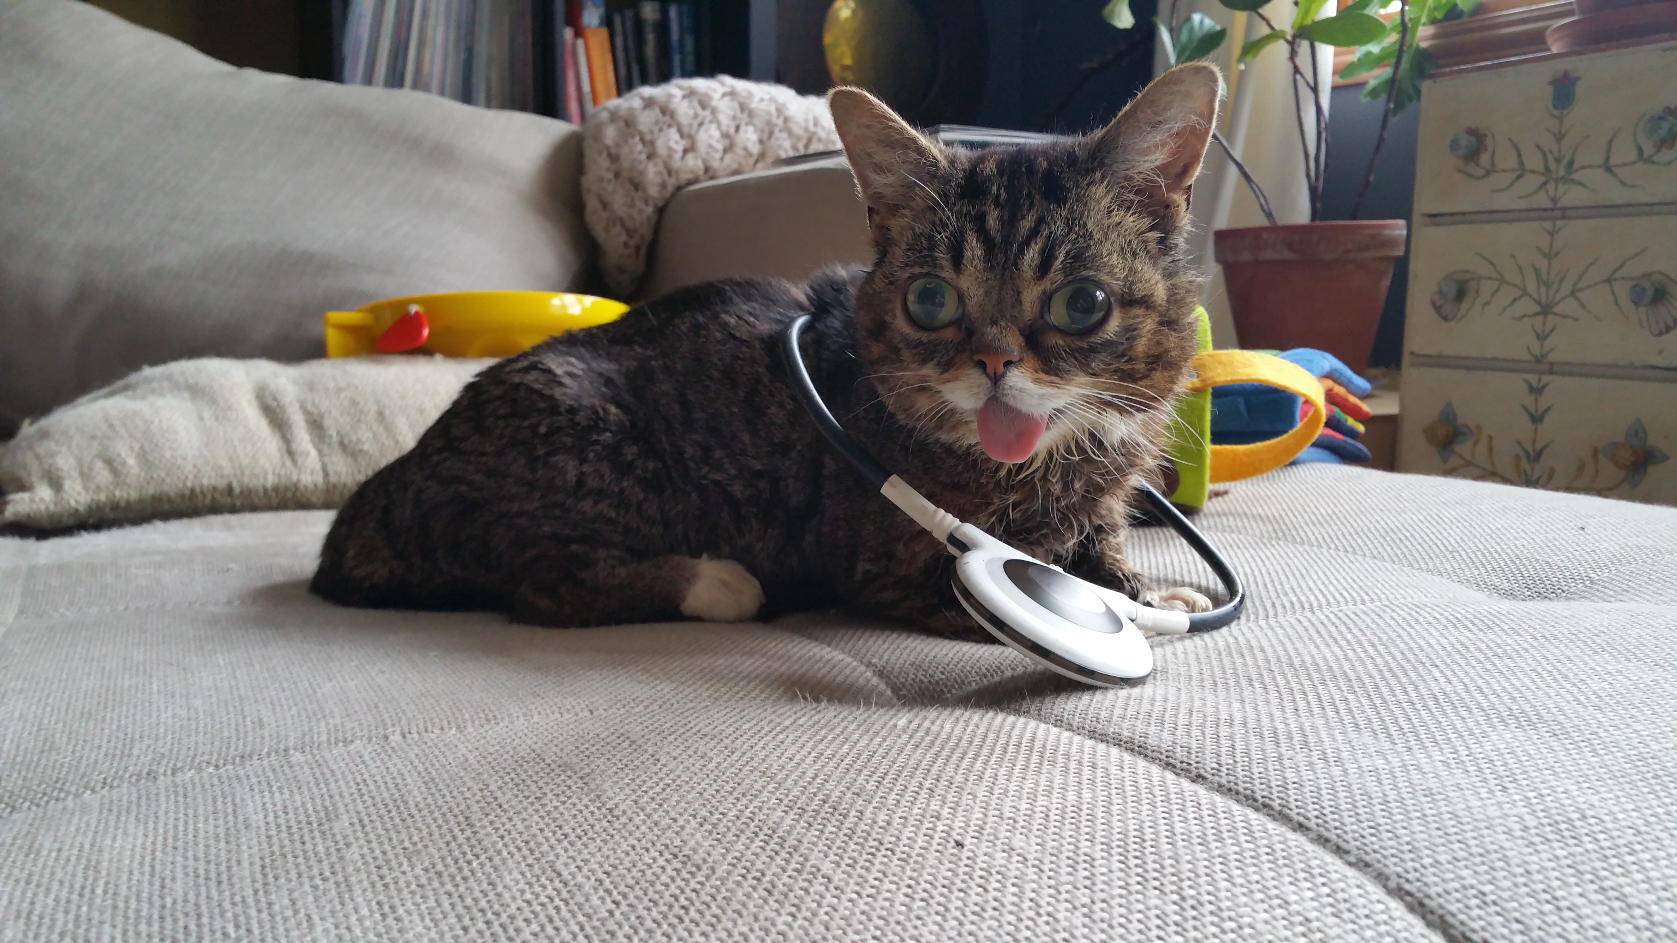
The Assisi Loop® 2.0 is now available at (Practice Name)! The Assisi Loop is a revolutionary device that naturally stimulates the body’s healing processes without the use of drugs or invasive surgery. As us about the Loop on your next visit! | 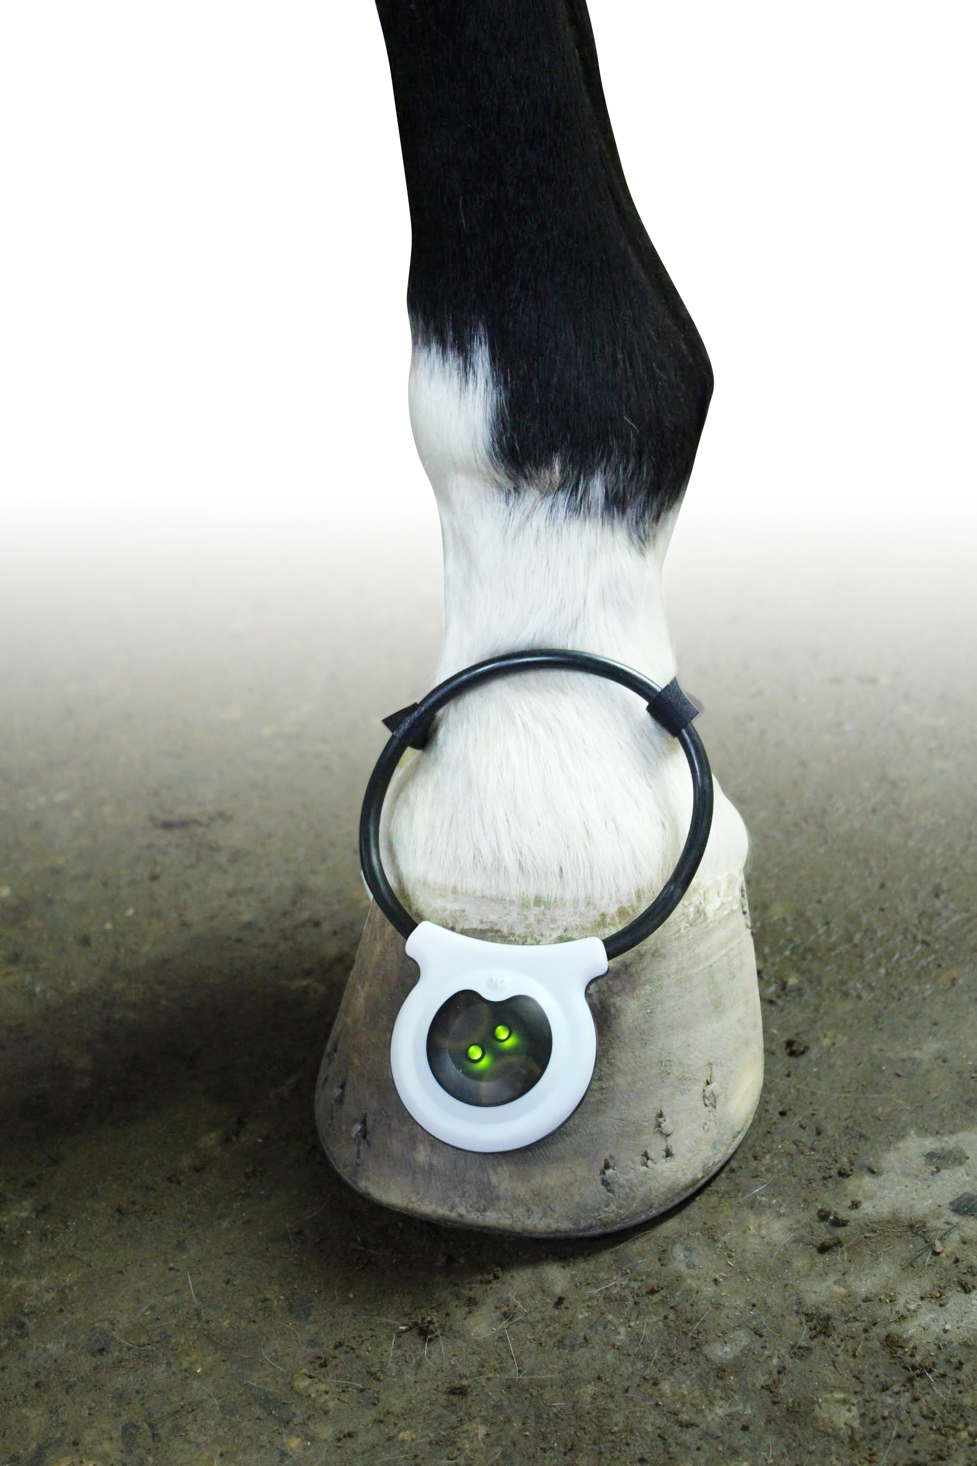

[NOTE: There are several images that you may use for your social media campaign, including cats, dogs, and horses. We highly recommend, however, that you add your own image of a patient using the Loop. Pet owners love seeing their animals on social media pages!]

