

**Assisi Animal Health**

**The Mechanism of Action (MOA) of**

**targeted Pulsed Electromagnetic**

**Field Therapy (tPEMF™)**

The design of Assisi Animal Health’s tPEMF™ signal for therapeutic applications is based on two PEMF technologies: radio frequency (RF) diathermy and bone growth stimulators (BGS).

Radio frequency diathermy, first used in the early 1900s, induces high amplitude electric fields which produce calibrated deep tissue heat. This therapeutic technique remains in use in physical therapy today. In the 1930s, it was discovered that this RF signal could be applied at much lower non-thermal amplitudes and still produce useful biological effects. These new RF PEMF devices have been cleared for use in human applications for the reduction of pain and edema and are reimbursed by Medicare for chronic wound repair.

In parallel, orthopedic surgeons discovered that everyday mechanical signals such as walking and jumping produced endogenous electrical currents in bone that help modulate bone cell activities such as growth and repair. This led to studies employing low-level direct electrical current and later pulsed electromagnetic fields that resulted in new bone formation. The FDA cleared the first PEMF bone growth stimulator device and waveform specifically for use in recalcitrant fracture healing. The BGS and RF PEMF signals both produce useful biological effects, including pain reduction. The Assisi RF PEMF signal was configured specifically to *target* normal endogenous anti-inflammatory and repair responses. This makes the Assisi tPEMF signal more effective than any other.

Assisi’s Technology

The Assisi Loop® generates a twice-per-second, 2-millisecond burst of a 27.12 Megahertz radio wave signal with an amplitude of 4 microtesla. This pulse-modulated field is non-thermal and non-invasive, yet is sufficient in strength to have therapeutic benefit.



Carrier: 27.12 MHz (ISM frequency – FCC defined)

Pulse Duration and Rate: 2 msec at 2 Hz

Duty Cycle: 0.4%

Peak Induced Magnetic Field (B): 4µT

Mean Deposited Energy Density (SAavg): 0.13 µWs/cm3

This RF signal is specifically targeted to enhance the binding of calcium (Ca2+) to calmodulin (CaM). This, in turn, accelerates the nitric oxide (NO) cascade, which regulates inflammation and healing. The Assisi targeted PEMF waveform therefore acts as a first messenger in tissue growth, repair, and maintenance.

The Loop’s carrier signal that transmits the pulsed magnetic field is tightly regulated by the FDA and FCC and is authorized for PEMF medical applications. Although the Loop’s signal strength is several orders of magnitude below the FCC exposure limit on cell phone signal strength, its unique signal characteristics enable it to enhance the normal anti-inflammatory and repair responses in challenged human and animal tissue.

Although, as mentioned above, several PEMF signals, including the BGS signal have been reported to reduce pain, not all PEMF signals deliver the same dose to the NO signaling cascade. Assisi’s tPEMF signal delivers the largest effective dose to the NO signaling pathway. No other PEMF signal has been purposely configured in this manner. As a result, other PEMF devices are unlikely to reduce pain or inflammation as rapidly or effectively as the Assisi Loop.

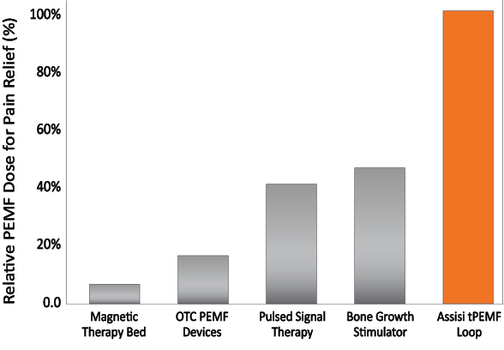

*Bar graph depicting the relative effectiveness of PEMF-labeled devices used in human and veterinary applications. This analysis is based upon the known effect of PEMF on nitric oxide (NO) signaling which, in turn, enhances the management of pain and inflammation1-6. The bars were created by evaluating the PEMF signal amplitude at the calcium binding step in the NO signaling pathway2. As may be seen, the Assisi Loop is expected to produce substantially faster pain relief.7-9*

The coil is the Loop’s component that delivers the therapeutic electromagnetic field. That field extends 4-5 inches on both sides from the plane of the coil. The effective strength of the field, its ability to induce the calcium/calmodulin effect, is not adversely affected by bandages, casts or orthopedic implants. Unlike other PEMF devices designed for dermatologic applications, the Loop’s therapeutic origins, the reduction of post-operative pain and edema, make it uniquely effective for treating many conditions in veterinary medicine.

References

1) Rohde C, Chiang A, Adipoju O, Casper D, Pilla AA. (2009). Effects of Pulsed Electromagnetic Fields on IL-1β and Post Operative Pain: A Double-Blind, Placebo-Controlled Pilot Study in Breast Reduction Patients. *Plast Reconstr Surg*, 125:1620-1629.

2) Pilla AA, Fitzsimmons R., Muehsam DJ, Rohde C, Wu JK, Casper D. (2011). Electromagnetic Fields as First Messenger in Biological Signaling: Application to Calmodulin-Dependent Signaling in Tissue Repair, *Biochem Biophys Acta*. 1810:1236-1245.

3) Pilla AA. (2012). Electromagnetic fields instantaneously modulate nitric oxide signaling in challenged biological systems. *Biochem Biophys Res Commun*. 426:330-333.

4) Nelson FR, Zvirbulis R, Pilla AA. (2013). Non-invasive electromagnetic field therapy produces rapid and substantial pain reduction in early knee osteoarthritis: a randomized double-blind pilot study. *Rheumatol Int.* 33:2169–2173.

5) Vincenzi F, Targa M, Corciulo C, Gessi S, Merighi S, Setti S, Cadossi R, Goldring MB, Borea PA, Varani K. (2013). Pulsed electromagnetic fields increased the anti-inflammatory effect of A₂A and A₃ adenosine receptors in human T/C-28a2 chondrocytes and hFOB 1.19 osteoblasts. *PLoS One*. 8(5):e65561.

6) Adravanti P, Nicoletti S, Setti S, Ampollini A, de Girolamo L. (2014). Effect of pulsed electromagnetic field therapy in patients undergoing total knee arthroplasty: a randomised controlled trial. *Int Orthop*. 38:397-403.

7) Hedén P1, Pilla AA. (2008). Effects of pulsed electromagnetic fields on postoperative pain: a double-blind randomized pilot study in breast augmentation patients. *Aesthetic Plast Surg.* 32:660-666.

8) Rawe IM, Lowenstein A, Barcelo CR, Genecov DG. (2012). Control of postoperative pain with a wearable continuously operating pulsed radiofrequency energy device: a preliminary study. *Aesthetic Plast Surg.* 36:458-463**.**

9) Strauch, B., et al. 2009. Evidence-Based Use of Pulsed Electromagnetic Field Therapy in Clinical Plastic Surgery. *Aesthetic Surgery Journal*